Name: Class:

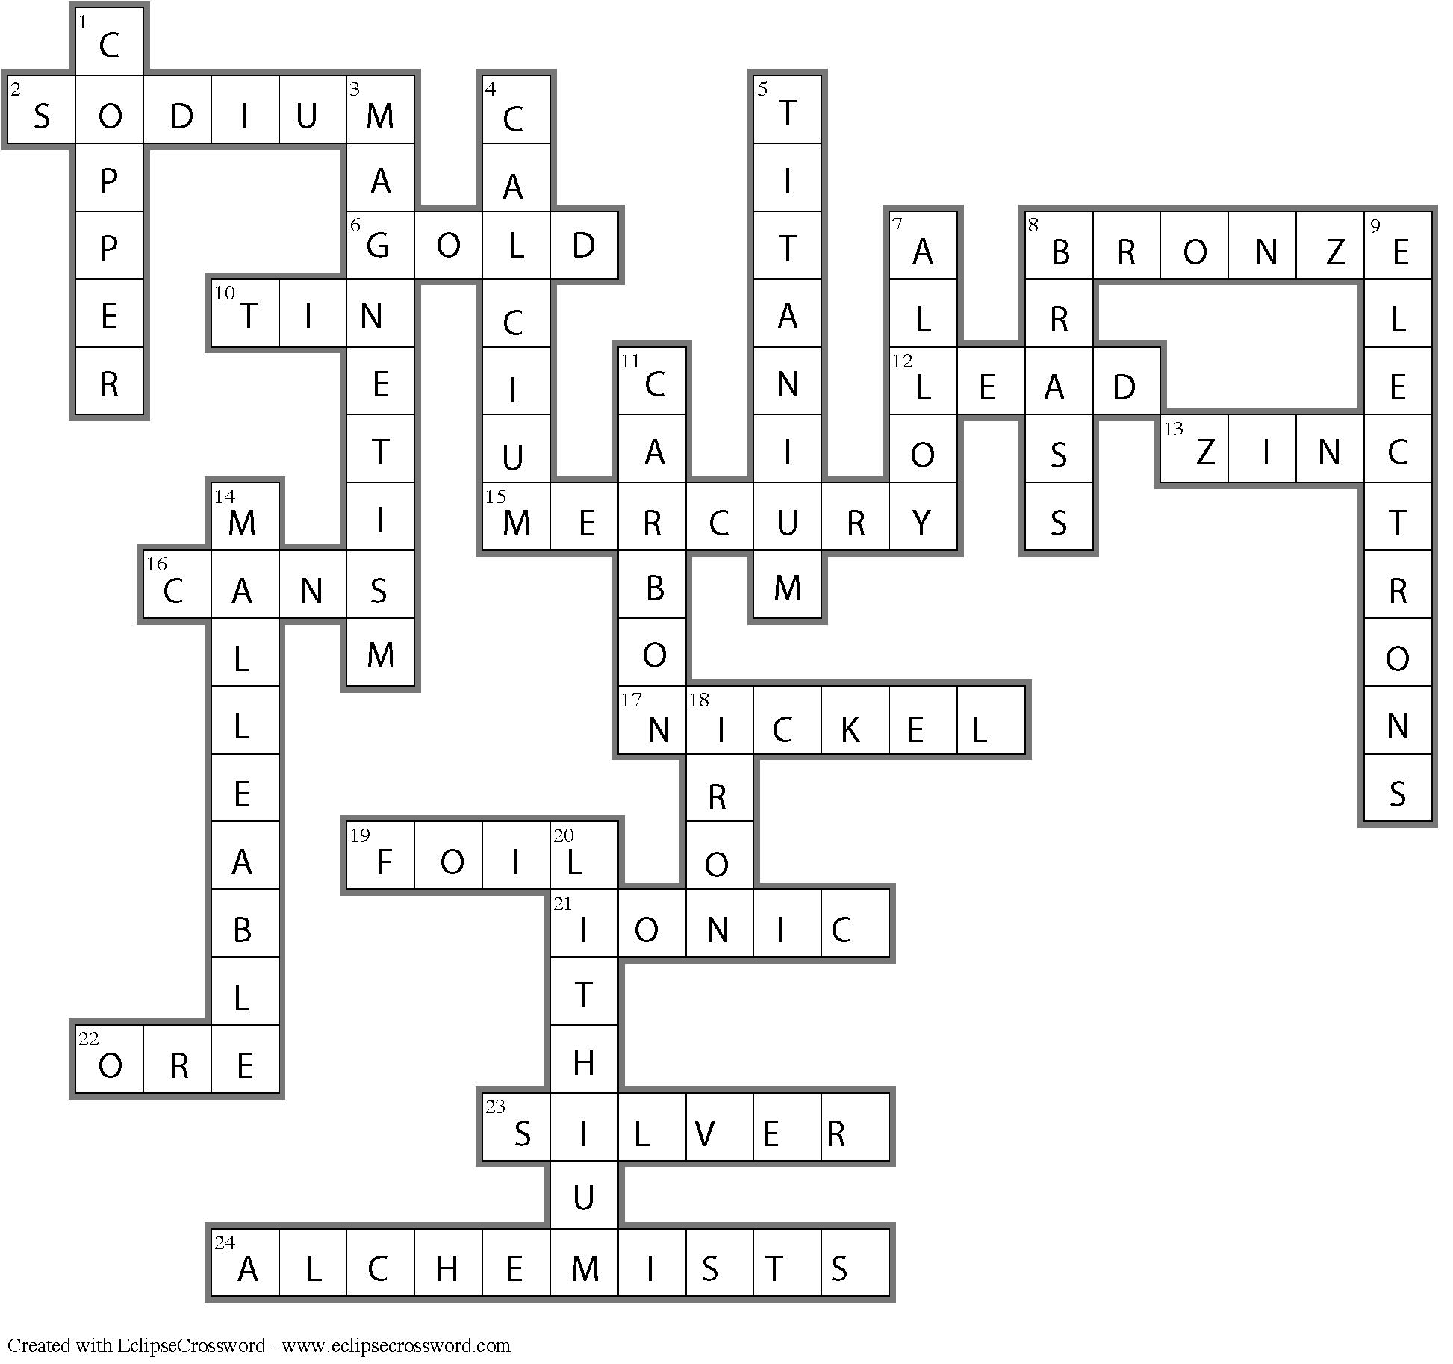
Across
2. SODIUM—The metal ion present in table salt.
6. GOLD—Which metal completes the quote ‘all that glitters is not …?’
8. BRONZE—The age dating from 3000 BC is named after this metal.
10. TIN—Copper and this metal combine to form bronze.
12. LEAD—A soft, dense metal formerly used in plumbing.
13. ZINC—A reactive metal often used in torch batteries.
15. MERCURY—A liquid metal associated with mad hatters.
16. CANS—Tin-plated iron is used to make these useful containers.
17. NICKEL—Combines with copper to produce Australian ‘silver’ coins.
19. FOIL—This form of aluminium is used in cooking.
21. IONIC— This type of bond exists in the compound formed when a metal reacts with a non- metal.
22. ORE—An economically useful mineral.
23. SILVER—One of the precious metals.
24. ALCHEMISTS—They sought to change lead to gold.

Down
1. COPPER— One of the metals that is not silver in colour.
3. MAGNETISM—Iron and some other metals exhibit this property.
4. CALCIUM—An important metal for healthy bones and teeth.
5. TITANIUM—The ninth most abundant element in the Earth’s crust.
7. ALLOY—A mixture of metals.
8. BRASS—An alloy of copper and zinc.
9. ELECTRONS—The conductivity of metals is due to the movement of these particles.
11. CARBON—This element is added to iron to produce steel.
14. MALLEABLE—A property shared by all metals.
18. IRON—The metal used to transport oxygen around your body.
20. LITHIUM—The metal with the smallest atomic number.

